**What changes when I start using ManageArtworks – Artwork Review Pro?**

**What’s in store:**

1. What’s right with emails for packaging artwork management?
2. Your current artwork approval process
3. What our customers said
4. What is ManageArtworks – Artwork Review Pro
5. What changes for you once you go Pro?

**Food for thought. Why do we use emails for packaging artwork management?**

1. It’s easy to use
2. No setup required
3. Requires no training or on-boarding
4. It’s free

It’s a unique identifier and you’ve been using it for approving packaging artworks everyday – which is amazing considering how complex the whole process is.

Nothing is more difficult than getting a packaging artwork approved as it goes through your internal departments, vendors, suppliers, agencies, and others who in turn send in their comments and different versions of the changes requested and you collate all of it on email and communicate it to the designer. Bottomline, managing artworks and getting them approved is hard so kudos to you for making it work.

Sure you can still collaborate and send files to each other. But it wont be long before your organization will scale (if it hasn’t already), post which communicating, reviewing and approving packaging artworks with, lets say, 30 people, instead of 5 will suddenly become more challenging than it was before.

**And that’s the issue with emails. They can’t keep up with growing businesses like yours. Email isn’t the problem. It’s the expectations we have from it.**

**Cue ManageArtworks – Artwork Review Pro**.

A platform that’s been built to address packaging artwork management challenges as you seamlessly collaborate on structured workflows, achieve regulatory compliance, and respond to market demands faster.

Let’s say your company’s next big product launch is on the horizon, and your team isn’t prepared at all. You still need to prepare the artwork brief, design the artwork, get approval from the necessary departments and send it off to the printer so that it reaches manufacturing on time. The sheer amount of work yet to be done is paralyzing, and your team is reeling under the pressure. What’s worse, you know that right when you’ve finished this project, it will all start again with the next one. Does this sound familiar?

This struggle is common among packaging artwork teams. Without an efficient artwork system, each project can feel like an uphill climb.

And you’re not alone. Here’s what some of our customers said before they started using our packaging artwork management platform:

“Follow-ups was the least favorite part of my profile. A chunk of my day would involve calling people and updating the review status on my excel sheet. The back and forth exchanges over emails never really yielded anything concrete. With over 150 SKUs to monitor we’d be often hard-pressed for time for validating the artwork.”

**Project Coordinator**

**Brazil-based Canned Foods Manufacturing Company**

“I used to proofread packaging artworks with a measuring scale to ensure that they comply with the FDA’s labeling regulations. My team would take printouts of the PDF file sent by the designer and spend hours trying to find minute differences on the pack’s inserts and text. Needless to say, this took days and there was a constant fear of non-compliance.”

**Regulatory Manager**

**U.S. based Wine Manufacturing Company**

“My project manager used to ask me for the latest version but as a designer, I always had 7 different versions from as many approvers. It created complications when the due date for the launch closed in.”

**Designer**

**U.K. based retailer**

“It was difficult keeping track of what stage was a particular artwork at, seeing that we are almost always working on 10 to 12 artworks at any given point of time. My manager would ask how many more versions of the artwork would we have to wait for before she saw the final approved version and what’s really stopping us to get it right the first time. These were tough questions our team didn’t have answers to.”

**Assistant Marketing Manager**

**Australian Skincare & Haircare company**

We have put together 4 key areas where Artwork Review Pro can make a difference. Think of your team and ask yourself a few questions:

1. How do we keep track of all the artwork projects and get everyone on the same page?
2. How do we reduce the number of times we change the artwork before we get it right?
3. How do we check all aspects of the artwork quickly and easily?
4. How can we make it simple to find all approved artworks?

If you can answer these questions, then you already have a solid way to manage your artwork projects. If you need help with one or more of the above areas or if you are thinking of ways to make your process more efficient, Artwork Review Pro might be the answer.

With Artwork Review Pro, you can essentially :

* Get everyone on the same page
* Launch your packaging artworks right-first-time
* Leverage proofing tools to ease your artwork review
* Quickly find what you’re looking for
* Have secure access to your packaging files 24×7

**How do we make this happen?**

**Automated Workflows**

* With an online, structured workflow, everyone knows what’s happening Artworks are centralized and people review it online without having to make copies or attach them with emails
* Seamlessly review and approve artworks by collaborating with internal and external agencies using studio artwork approval workflows and print proof approval workflows
* You’re always on top of where your artworks are by receiving alerts and notifications for follow-ups
* Track projects in real-time to see where your artworks are currently at
* Verify who did what and when with audit logs instantly

[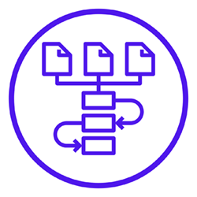](https://www.manageartworks.com/blog/what-changes-when-i-start-using-manageartworks-artwork-review-pro/)

**Automated Proofing Tools**

* Users reduce the number of hours spent on manual proofreading of the artwork
* Errors are identified faster leading to reduction in number of reworks and faster approval cycles
* With pixel comparison, our system automatically compares each individual pixel between two different versions of the artwork which leads to far more efficient comparison results

[](https://www.manageartworks.com/blog/what-changes-when-i-start-using-manageartworks-artwork-review-pro/)

**Checklists**

* With access to department-wise checklists, you can now select “Yes”, “No” or “Not Applicable” and optionally put a comment for each checklist item
* This helps you stay compliant, significantly reduce iterations, create artworks right-first-time and respond faster to market demands
* Having access to checklists will help new people joining the organization to quickly be inducted into the process

[](https://www.manageartworks.com/blog/what-changes-when-i-start-using-manageartworks-artwork-review-pro/)

**Asset Library**

* If your artwork files are scattered across chats, emails, and spreadsheets, storing them in a cloud-based, centralized, secure digital asset library is your best bet
* Was the file name Finaldraft_003 or Draft_final03? You needn’t think more. Just search and retrieve files using metadata within seconds
* Store and repurpose files of any size or format. This helps multiple departments access multiple files with ease.
* Set user – access permissions so that you’re sure that only specific people have access to certain files. This is particularly useful while dealing with external agencies.

[](https://www.manageartworks.com/blog/what-changes-when-i-start-using-manageartworks-artwork-review-pro/)

**Reporting**

**Access key metrics like:**

* Average time taken for an artwork approval so that you can foresee and plan your artwork projects accordingly
* Percentage of right-first-time projects so that you have clarity on your team’s efficiency
* Iteration reports help you understand where errors occur and why

[](https://www.manageartworks.com/blog/what-changes-when-i-start-using-manageartworks-artwork-review-pro/)

The Artwork Review Pro helps teams move**from a people-dependent scenario to a process – dependent scenario**.

Refining your team’s artwork process can help you gain efficiencies that allow your team to be more productive. Although every team is different, Artwork Review Pro can streamline efforts, save money, and enhance the quality of work.

**Need we say more?**

**To know more about the Artwork Review Pro  
system, please**[**Click here**](https://www.manageartworks.com/features-artwork-review-pro/)

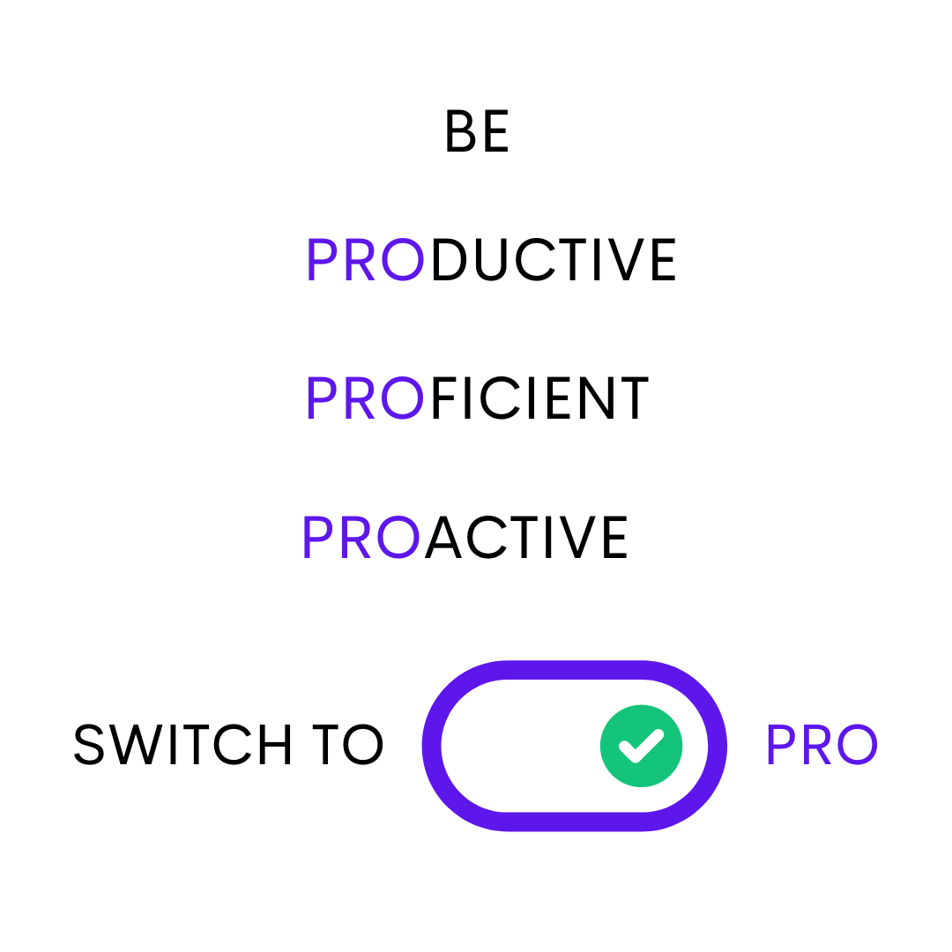

**No Setup Costs | Free for 10 artworks | 24×7 eMail & Chat Support**

[**Click here to Sign Up!**](https://www.manageartworks.com/blog/what-changes-when-i-start-using-manageartworks-artwork-review-pro/)